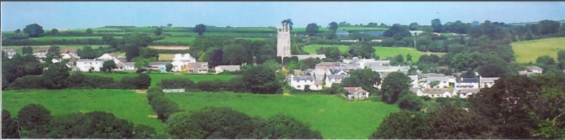
28th December 2025
Dear Councillor,
You are summoned to attend a meeting of North Hill Parish Council on Monday 5th January 2026 at 7.30pm in the Village Hall.
Please find attached the agenda for our meeting. We ask that if any member of the public has issues, they would like to raise that they contact the clerk prior to the meeting so that we can best manage them.
Please remember that the time allotted for Matters of Community Concern is not a forum to discuss what has taken place during this meeting and that any matter raised here would likely be added to the NEXT meeting agenda for discussion.
Yours faithfully,
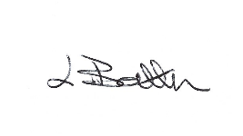
Lena Batten, Clerk to the Council
Members of the public are welcome to attend the meeting. However, we would like those attending to register prior to the meeting by emailing the Parish Clerk. Email: clerk@northhillparish.org.uk
AGENDA
- TO RECEIVE APOLOGIES:
- CODE OF CONDUCT : a) TO RECEIVE DECLARATIONS b) TO GRANT DISPENSATIONS:
3. PUBLIC COMMENTS ON ITEMS ON THE AGENDA ONLY:
4. TO RECEIVE AND APPROVE THE MINUTES OF THE 1st DECEMBER 2025 FULL COUNCIL MEETING:
5. ANY MATTERS ARISING FROM PAST MINUTES NOT ON THE CURRENT AGENDA:
6. TO CONSIDER PLANNING APPLICATIONS RECEIVED FROM CORNWALL COUNCIL BY DATE OF THIS MEETING:
6.1 PA25/08719 – Batten Mill, Mill Lane, North Hill – Listed building consent to re roof property – comments submitted on the 17th December 2025 to confirm North Hill Parish Council had no objection as works needed to be carried out to prevent loss of historic fabric.
6.2 PA25/09208 – Land North West of Clampit Farm, Linkinhorne – Construction of general purpose agricultural building and stone access track and stone hard standing – no site visit arranged due to nature of the application.
6.3 PA25/06850 – Yellow on the Broom, Blythes Farm, North Hill, PL15 7PG - Application for Permission in Principle for construction of dwellings (minimal number 4, maximum number 9) – email received to request an agree, disagree or request a referral to planning committee – clerk submitted the general consensus which was to refer to planning committee, a Cllr is required to attend.
7. ANY APPLICATIONS RECEIVED BEFORE THE DATE OF THIS MEETING: None.
8. TO REVIEW CORRESPONDENCE AND TO AGREED RESPONSES REQUIRED:
8.1 To note for information an increase of £1.00 per month for bank charges due to commence on the
1st February 2026 taking the cost from £6.00 to £7.00 per month.
8.2 To consider / resolve compliance with Assertion 10 by change of email addresses and adoption of
Data protection Policy.
8.3 To receive an update from one Councillor in relation to North Hill Parish’s emergency planning
procedures.
8.4 To consider / resolve whether to make a donation from CIL funds to Coads Green Village Hall
towards their play area.
8.5 To consider / resolve submitting an expression of interest to CHIP for speed management in
Middlewood / Berrio bridge.
8.6 To consider / resolve sharing your views regarding Cornwall’s bus services.
8.7 To consider / resolve any response to National grid who are required to replace some apparatus at
Congdon’s Shop Green, registered common land.
8.8 To receive email in relation to the 20mph speed limit and consider any response.
8.9 To consider / resolve whether to make the annual £20.00 donation to the host of the defibrillator at
Bathpool.
9. TO REVIEW DETAILS FOR NORTH HILL PARISH COUNCIL CEMETERY:
9.1 To consider / resolve putting the cemetery path works out to tender as agreed at the August 2025
meeting.
10. APPROVAL OF THE LIST OF PAYMENTS / RECEIPTS FOR DECEMBER 2025 & TO RECEIVE DECEMBER 2025 BANK STATEMENT:
10.1 AUTHORISATION OF EXPENSES INCLUDING SALARY:
i) £18.00 (PAYE G. Pollard payroll, dd)
ii) £703.12 (Lena Batten, Salary Dec)
iii) £43.64 (room rent)
iv) £149.87 (Lena Batten, N.I. and tax Dec)
v) £25.00 (Royal British Legion, wreath donation)
vi) £13.98 (magnets for noticeboards, Amazon)
vii) £42.00 (planning training)
10.2 RECEIPTS:
i) £339.00 (Cornwall Council, grant maintenance of St Torney’s Church)
ii) £660.23 (Cornwall Council, grant maintenance of footpaths)
10..3 To receive bank statement:
Bank Statement as of 30th December 2025 £17,673.08
11. TO REVIEW MONTHLY BUDGET RECONCILIATIONS:
11.1 Budget Sheet Attached.
12. TO REVIEW MONTHLY RAG: (Red, Amber, Green)
12.1 RAG Sheet attached.
13. REPORT FROM CORNWALL COUNCIL WARD MEMBER COUNCILLOR PARSONS:
14. ITEMS FOR INCLUSION AT THE NEXT MEETING:
15. DATE & TIME OF NEXT MEETING:
16. CLOSE OF BUSINESS:

